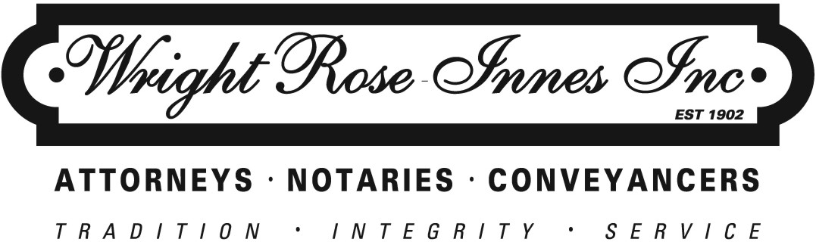

Your ref.

Shaun Dewberry
shaun@dewberry.co.za
By e-mail

Our Ref.
182446/Graeme Carrington/ap/G200

e-mail : graemec@wri.co.za
Direct Fax : 086 630 3905
26 June 2012
By e-mail

Dear Sir

Re: our client: net dynamics

Kindly note that we represent Net Dynamics (“our client”) and are instructed by our client to address this letter to you on their behalf.

As you are aware, our client is the service provider to a number of internet radio stations in South Africa, including but not limited to 2Oceans Vibe Radio, Ballz Radio, and KingfisherFM.

Our client has referred us to your blog entitled “The Truth Behind Streaming Internet Radio in South Africa” and has sent us an audio transcript of the interview which you conducted with Darren Scott on Ballz Radio on the 25th June 2012.

We also understand that you have posted similar content as contained in your aforesaid blog, on your Twitter page as well as on Facebook.

In all of the abovementioned publications, being your blog, your Twitter page, your Facebook page and in your verbal interview with Darren Scott on Ballz Radio yesterday, you have defamed our client’s good name and reputation, by inter alia stating that:

- Our client’s listenership statistics are complete fabrications.

- Our client’s listenership statistics are utter nonsense.

- Our client’s listenership statistics are lies.

- Our client has fooled their clients in regard to such statistics.

- Our client has pulled the wool over the eyes of our client’s clients with such listenership statistics.

All of these statements are highly defamatory of our client who enjoys an un-impeached reputation in the industry.

Not only are these statements and publications highly defamatory of our client, but they were clearly made by you with malicious intent, given your association with our client’s competitors.

In addition to the above, not only are these statements false and untrue, but you published these statements of and concerning our client, and our client’s listenership statistics, which statistics are derived directly from the platforms which our client provides to its clients, without first inviting our client to comment on your research and the arguments which you use to attempt to justify your opinion.

Basic principles of fairness and justice, require you to invite our client to challenge or contradict your opinions, before you publish such opinions of and concerning our client, particularly in circumstances where you are well aware that such opinions which you have published, are highly controversial, potentially damaging to our client and their clients, and based on flawed research, assumptions and presumptions.

We do not intend in this letter to debate with you, whether your opinions and research have any merit whatsoever (although our client is adamant that there is no merit whatsoever in your contention). The purpose of this communication is instead to demand, as we hereby do, that:

- Within 6 (six) hours of receipt by you of this communication, that you remove your blog, your posting on your Twitter page and your posting on your Facebook page, of all of these articles published by you concerning this subject matter and our client.

- That on all of these mediums, being your blog, your Twitter page and your Facebook page, that you publish a retraction of your defamatory statements of and concerning our client and apologise to our client for the reputational damage caused to our client.

- That in doing so you concede that prior to publishing these issues on your blog, your Twitter page and your Facebook page, that you should have first called on our client to dispute your findings and to provide you with their comment.

- That your apology specify that you regret any offence or reputational damage which you may have caused to our client in the circumstances, having published such unfair and unacceptable statements of and concerning our client, which expressly convey the fact that you consider our client to be dishonest and unethical in their dealings with their clients.

- That you confirm within the 6 (six) hour period aforesaid by return e-mail, that you have so complied.

We confirm that should you fail, refuse and/or neglect to comply with our reasonable demand set out above, by deleting these defamatory publications and publishing a retraction and apology as demanded, our client will immediately instruct us to:

- Launch an urgent High Court interdict application against you, in terms of which the High Court will be asked to order that you immediately remove these defamatory publications from all social media, websites and the like, that you publish a retraction and apology, and that you are interdicted in future from publishing any such defamatory statements of and concerning our client. Should we launch such High Court application against you in the absence of your compliance with our client’s reasonable demand, we will ask the High Court to simultaneously order that all of the legal costs incurred by our client on the most punitive possible scale are to be paid by you

- Claim from you by way of damages, any financial loss that our client may suffer as a consequence of your defamatory and malicious publications of and concerning our client.

All our client’s rights remain strictly reserved.

Yours faithfully

WRIGHT, ROSE-INNES INC.

